**JAVASCRIPT ASSIGNMENT**

**Write a function to sum two numbers**

**Using + operators**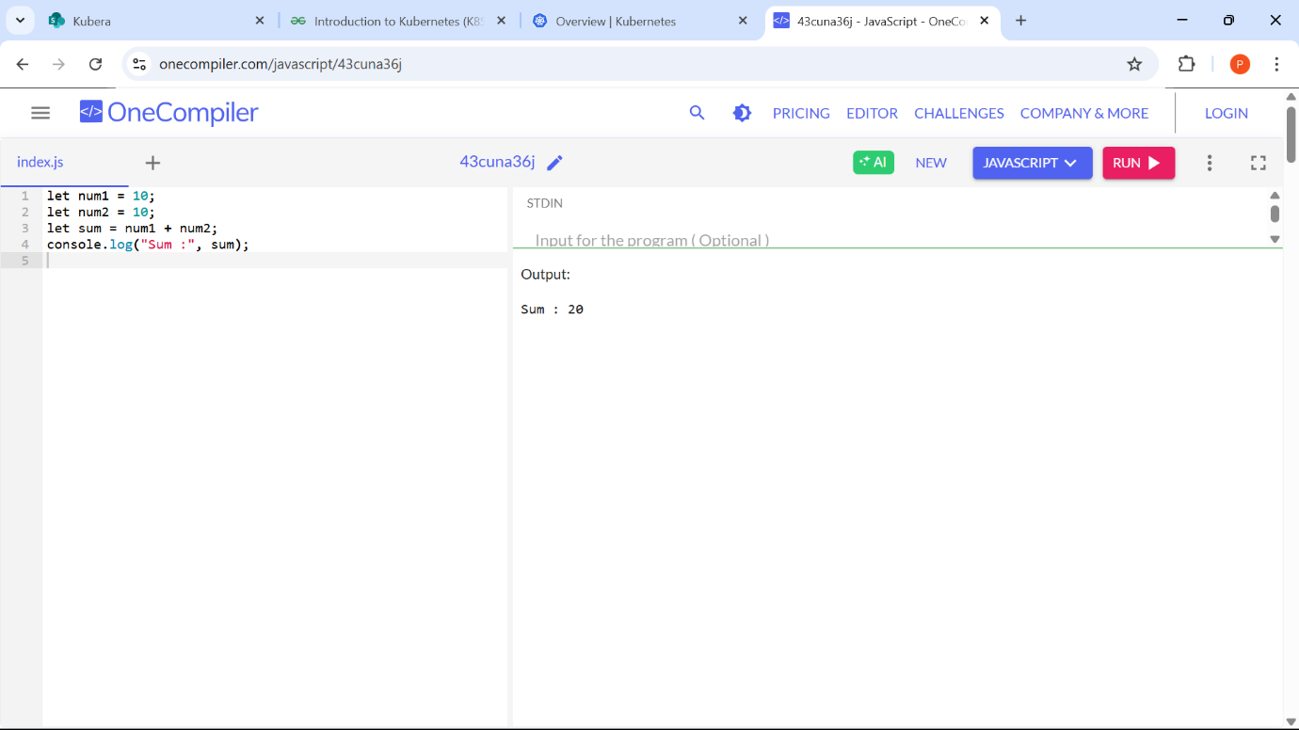

**Using function**

**Using Arrow function**

**Using Addition Assignment operator**

**Convert a regular function to an arrow function**

**Arrow function without parameters**

**Arrow function with single parameters**

**Arrow function with multiple parameters**

**Arrow function with default parameters**

**Return object literals**

**Async arrow function**

**Create a counter function using closures**

**Define an object representing a car with properties and a method**

**Create a counter function using closures**

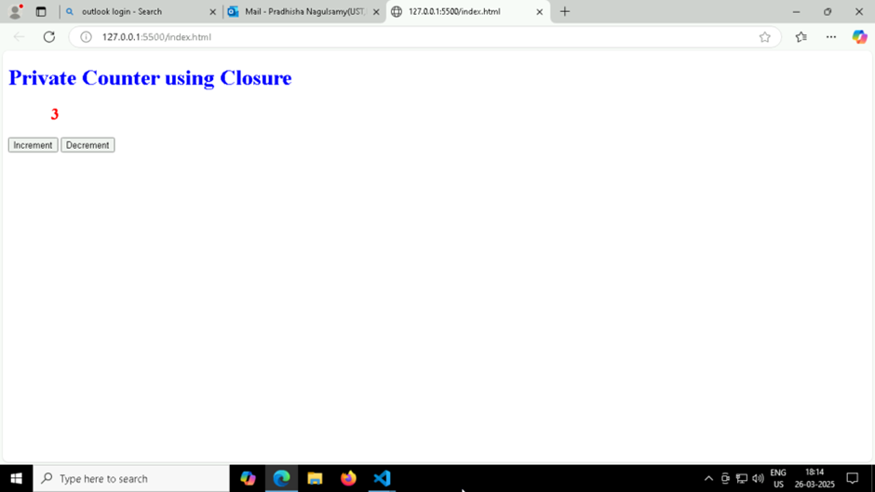

**Create a simple web page displaying "Hello, World!" using JavaScript.**

**Pop-Up on Client Side**

